**DAILY ONLINE ACTIVITIES SUMMARY**

|  |  |  |  |  |  |  |  |  |
| --- | --- | --- | --- | --- | --- | --- | --- | --- |
| **Date:** | **11/06/2020** | | | | | **Name:** | **Shwetha** | |
| **Sem & Sec** | **8th B** | | | | | **USN:** | **4AL16CS101** | |
| **Online Test Summary** | | | | | | | | |
| **Subject** | | **SMS** | | | | | | |
| **Max. Marks** | | **60** | | **Score** | | | **60** | |
| **Certification Course Summary** | | | | | | | | |
| **Course** | **Introduction to information security** | | | | | | | |
| **Certificate Provider** | | | **Great learning** | | **Duration** | | | **5.5hr** |
| **Coding Challenges** | | | | | | | | |
| **Problem Statement:**  **Python program to rotate an array by d elements** | | | | | | | | |
| **Status: Solved**  **Solution link: https://github.com/alvas-education-foundation/Shwetha-** | | | | | | | | |
| **Uploaded the report in Github** | | | | | **Yes** | | | |
| **If yes Repository name** | | | | | **Shwetha-** | | | |
| **Uploaded the report in slack** | | | | | **Yes** | | | |

Online test details:

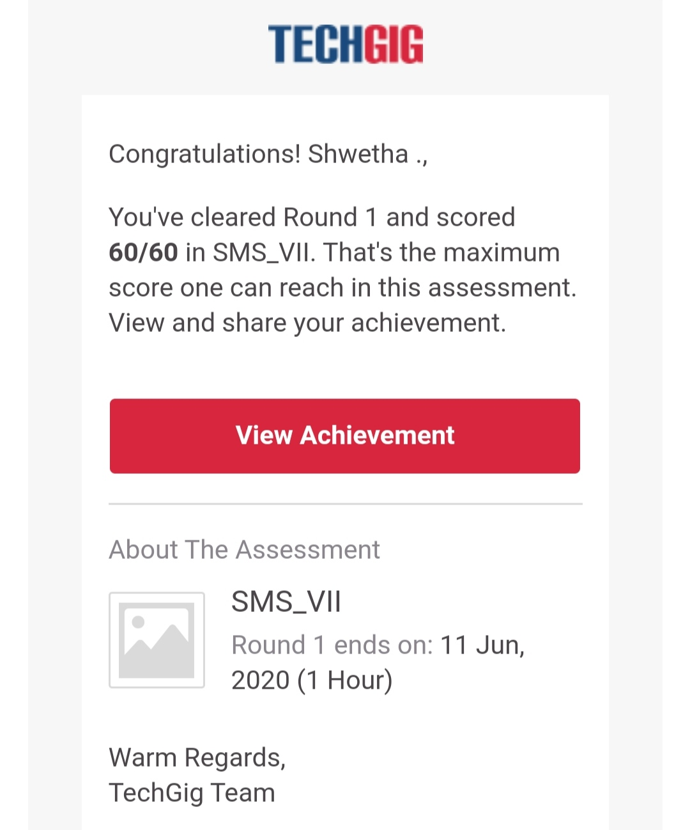

Certification Course Details:

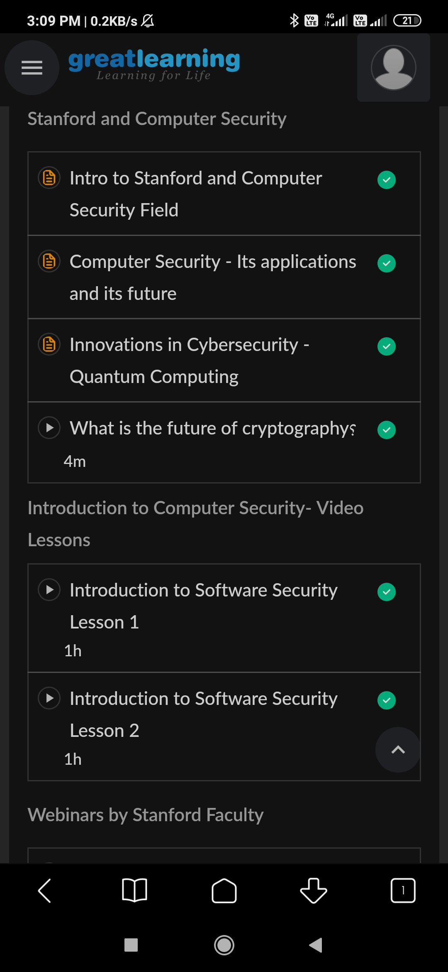

*Coding Challenges Details:*

defleftRotate(arr,d,n):

for i in range(d):

leftRotatebyOne(arr,n)

defleftRotatebyOne(arr,n):

temp=arr[0]

for i in range(n-1):

arr[i]=arr[i+1]

arr[n-1]=temp

defprintArray(arr,size):

for i inrange(size):

print("%d"%arr[i],end="")

arr=[1,2,3,4,5,6,7]

leftRotate(arr,2,7)

printArray(arr,7)